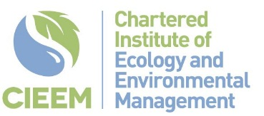

Early career Network and Knowledge share
14th Novemebr 2025
Lead Sponsor  Support Sponsor 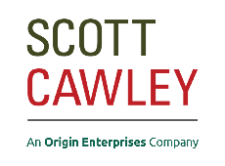

Chair: Aebhin Cawley, Ireland Vice President
14:00 | Welcome Reception – Tea/coffee and biscuits on arrival
14.15 | Opening address: Aebhin Cawley, CIEEM Ireland Vice President
14.20 | Keynote Speaker: Brambles and Backroads: Finding Your Path in Ecology  Collie Ennis, Biodiversity Officer, Trinity College Dublin
14:50 | Petals, Gills, Legs and Wings: Inspiration on Inchagoill  Jo Ruane, MKO
15:00 | A “Spicy Brain” Almanac – Navigating the Early-Career Ecology Landscape with Neurodiversity  Simon O’Carroll, Scott Cawley Ltd.
15:10 | Break
15:40 | Starting out in Green Careers – A personal journey of Challenges and Opportunities  Malena Thren, MKO
15:50 | CIEEM Capacity Research Project  Fiona Nulty, BioSense
16:00 | How I Got Here: Stories, Tips & Sector Truths  Curious about where your career could take you? This dynamic panel brings together professionals from key ecology sectors—Public, Private, NGO and Academia - to share their experiences and insights. Designed for early career attendees, the session offers practical advice, sector-specific stories, and candid tips from key players. Whether you're exploring options or ready to dive in, this is your chance to hear firsthand information on what it's really like on the inside—and how they got there.  Chair:  Alex Hayden  Panellists:  Ricky Whelan, Biodiversity Officer, Offaly County Council  Conor McKinney, Wild Belfast/Starling Ecology  Oonagh Duggan, Birdwatch Ireland  Yvonne Buckley, Co-Centre for Climate + Biodiversity + Water, Trinity College Dublin  Paul Scott, National Parks and Wildlife Service (NPWS)
17:00 | Drinks Reception, Food and Networking
18:30 | Finish

