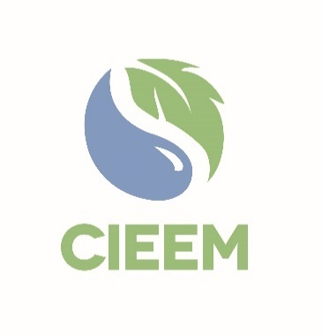 | Awards 2025  Best Practice Large Scale and Small Scale Practical Nature Conservation Awards Nomination Form

Please read the Nomination Form Essentials in 2025 Awards | CIEEM carefully before you begin to ensure you’re aware of all the submission guidelines and judging criteria.

Nominator
Full Name:
Membership Number:
(If known)
Email:
Connection to the project:
☐ | I declare that to the best of my knowledge the information provided is accurate and complete. The supporting statement at the end of this form has been completed.
☐ | I consent to the project being entered in an alternative category at the judges’ discretion.

Project put forward for the Best Practice Large scale and Small scale Practical Nature Conservation Awards
Project Name*:
Name of Implementor Organisation(s) / Partnership*:
Email Details for Project Lead**:
I am nominating the below project for the following award:  (Please only select one) | Large-Scale Project Mitigation | ☐
 | Small-Scale Project Mitigation | ☐

* N.B.: These would be the details that would appear on any certificate/trophy should the nomination be shortlisted.
** N.B.: This is the individual who will be contacted should the entry be Shortlisted.

At CIEEM, we are always looking to expand our new webinar programme. If the project is shortlisted for an award, would you be interested in giving a webinar? Yes ☐ No ☐

N.B: Please ensure that the Supporter has completed their section, which can be found at the end of this application, before submission to CIEEM.

Nominator
Please outline below, with reference to the four award criteria, why this project should receive a CIEEM Best Practice Award.

Your nomination text and supporting information will be the only pieces of information that the judges use in their shortlisting. Please be as specific and evidence-based as possible when making the case for your project and be sure to address all the award criteria.

Practical Nature Conservation
Enhances biodiversity, ecosystem functioning and sustainable development. The scale of the project is determined by the cost of the ecological component of the project. Small-scale projects are defined as costing less than £100,000 with large-scale projects costing more than £100,000.

Please provide a brief description in no more than 500 words of the project. Include the date in years that work was undertaken, any monitoring carried out and the total cost of the ecological component. Nominations should seek to give an ecologically balanced picture of the costs, benefits, gains and losses of the project. Where possible, monitoring-based indicators should be submitted to demonstrate the success of the project.

The number of words in the following 3 boxes combined, should total no more than 1,000.

Project contributes to the conservation and enhancement of biodiversity: 20 points.

Project contributes to enhancement and/or restoration of ecosystem functioning and/or services: 20 points.

Project demonstrates value for money in terms of impact: 10 points.

Supporter

Full Name:
Membership Number:
(If applicable)
Organisation:
Email:
☐ | I have completed the supporting statement and declare that to the best of my knowledge the information provided is accurate and complete. I have not worked directly on the project.

Please summarise the impact of the project against the award criteria in no more than 500 words. The judges are looking for evidence of the project’s merits and achievements. If you are only able to provide a professional opinion about the project, please ensure this is relevant to the nomination and supported with a coherent explanation as to why you think it demonstrates best practice.

Please email this entry form and your supporting information and three photos for use in the Awards presentation and booklet if shortlisted to awards@cieem.net by the closing date of Friday 10th January 2025. Supporting information must be submitted as one PDF document, with a maximum of six pages and no more than three external links included. Please ensure you include any photos, maps, graphs and diagrams within the six page limit. If you have any queries, please email or call 01962868626.

Nomination Check List
Project and organisations/partners nominated for the award have been spell checked.
N.B. These are the details that will appear on any certificate/trophy should the project be shortlisted.

Brief description of project completed.
Ensure 3 criteria boxes are completed, clearly explaining how the project meets the criteria.
Supporter information and statement completed.
Ensure any photos, maps, graphs and diagrams are only included within your six page supporting info PDF and not in the nomination form.
N.B. Failure to comply with this may result in your nomination becoming ineligible.
Ensure your nomination form is submitted as a Word document.
Send three high quality photos alongside your nomination form and supporting information for use in the Awards presentation and booklet if shortlisted.

