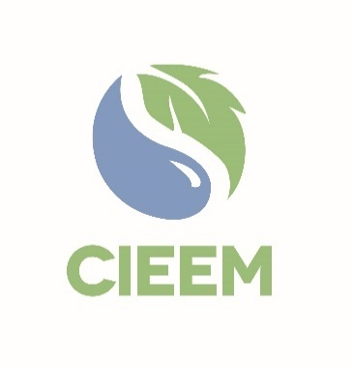 | Awards 2025  NGO Impact Award  Nomination Form

Please read the Awards Entry Guidance found on the 2025 Awards | CIEEM webpage carefully before you begin to ensure you are aware of all the submission guidelines and judging criteria.

Nominator
Full Name:
Membership number:
(if known)
Job Role:
Email:
Connection to the Person or Initiative Nominated:
☐ | I declare that to the best of my knowledge the information provided is accurate and complete.

Project or Initiative Nominated for the NGO Impact Award
Organisation/Partnership Name*:
Project/Initiative Name*:
Project/Initiative Contact Email**:

* N.B.: These would be the details that would appear on any certificate/trophy should the nomination be shortlisted.
** N.B.: This is the individual who will be contacted should the entry be Shortlisted.

Nominator
Please explain below why the project or initiative you have nominated should receive the NGO Impact Award 2024. Please note The total number of words for the 3 criteria boxes should be no more than 1,000 words in total.

Your nomination text and supporting information will be the only pieces of information that the judges use in their shortlisting. Please be as specific and evidence based as possible when making the case .

Overall Impact of Initiative, highlighting key outcomes, including positive changes or enhancements achieved for the conservation of the natural environmental as a direct result of the initiative: 20 points.

Engagement with relevant stakeholders, including beneficiaries, partners, and the wider community, ensuing their input was acknowledged and integrated into the planning and implementation of the initiative: 10 points.

Creativity and/or Innovation (such as through effective use of limited available resources) demonstrating how the initiative achieved or exceeded its original objectives: 10 points.

Please email this entry form, your supporting information and three photos for use in the Awards presentation and booklet if shortlisted to awards@cieem.net by the closing date of 17th January 2025 Supporting information must be submitted as one PDF document, with a maximum of six pages and with no more than three external links included. Please ensure you include any photos, maps, graphs and diagrams within the six page limit. If you have any queries, please email or call 01962868626.

Nomination Check List
Name of person(s) or initiative nominated for the award have been spell checked.
N.B. These details will appear on any certificate/trophy should the programme be shortlisted.
Ensure 3 criteria boxes are completed, clearly explaining how the project meets the criteria.
N.B. Words here are included in the word count for the criteria boxes.
Ensure any photos, maps, graphs and diagrams are only included within your six page supporting information PDF and not in the nomination form.
N.B. Failure to comply with this may result in your nomination becoming ineligible.
Ensure your nomination form is submitted as a Word document.
Send three high quality photos alongside your nomination form and supporting information for use in the Awards presentation and booklet if shortlisted.

