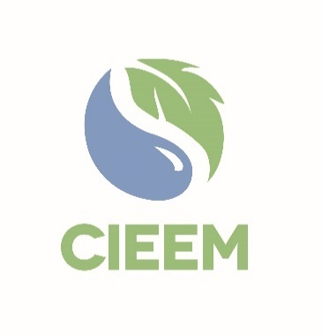 | Awards 2025  Consultancy of the Year Award  Nomination Form

Please read the Awards Entry Guidance found on the 2025 Awards | CIEEM webpage carefully before you begin to ensure you are aware of all the submission guidelines and judging criteria

Nominator
Full Name:
Membership Number:
(If known)
Email:
Connection to the Consultancy Nominated:
I am nominating the below consultancy for the following award:
(Please only select one.)
 |  |  | Medium Consultancy of the Year | ☐
 |  |  | Large Consultancy of the Year | ☐
☐ | I declare that to the best of my knowledge the information provided is accurate and complete.

Consultancy nominated for the Consultancy of the Year Award
Company/Organisation Name*:

Company Contact Details**:
Number of employed Ecologists and/or Environmental Managers:
Number of current CIEEM Members and member-applicants:
* N.B.: These would be the details that would appear on any certificate/trophy should the nomination be shortlisted.
** N.B.: This is the individual who will be contacted should the entry be Shortlisted.

Nominator
Please explain below why the consultancy you have nominated should receive the Consultancy of the Year Award 2024. Please note The total number of words for the 5 criteria boxes should be no more than 1,500 words in total.

Your nomination text and supporting information will be the only pieces of information that the judges use in their shortlisting. Please be as specific and give evidence-based information in making your case. The judges are looking particularly for evidence of success to address all the award criteria.

Consistent delivery of high-quality practical outcomes that benefit business and the economy as well as nature and/or people’s connection with nature. 40 points.

Evidence of sharing learning and good practice externally.15 points.

Evidence of how the company is working to reduce its own carbon footprint and encouraging others to do so:15 points.

Commitment to undertaking CPD and supporting the professional development of staff: 15 points.

Promotion of the profession: 15 points.

Please email this entry form, your supporting information and three photos for use in the Awards presentation and booklet if shortlisted to awards@cieem.net by the closing date of 17th January 2025. Supporting information must be submitted as one PDF document, with a maximum of six pages and with no more than three external links included. Please ensure you include any photos, maps, graphs and diagrams within the six page limit. If you have any queries, please email or call 01962868626.

Nomination Check List
Name of the Company nominated for the award has been spell checked.
N.B. These details will appear on any certificate/trophy should the company be shortlisted.
Ensure 5 criteria boxes are completed, clearly explaining how the consultancy meets the criteria.
N.B. Words here are included in the word count for the criteria boxes.
Ensure any photos, maps, graphs and diagrams are only included within your six page supporting information PDF and not in the nomination form.
N.B. Failure to comply with this may result in your nomination becoming ineligible.
Ensure your nomination form is submitted as a Word document.
Send three high quality photos alongside your nomination form and supporting information for use in the Awards presentation and booklet if shortlisted.

