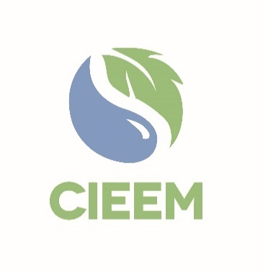 | Awards 2025  Climate and Nature  Action 2030 Award  Nomination Form
Please read the Awards Entry Guidance found on the 2025 Awards | CIEEM webpage carefully before you begin to ensure you are aware of all the submission guidelines and judging criteria.

Nominator
Full Name:
Membership number:
(if known)
Job Role:
Email:
Connection to the Person or Initiative Nominated:
☐ | I declare that to the best of my knowledge the information provided is accurate and complete.

Person(s) or Initiative Nominated for the Climate and Nature Action 2030 Award
Individual(s) or Initiative Name*:
Individual(s) or Initiative
Contact Email (if known)**:

* N.B.: These would be the details that would appear on any certificate/trophy should the nomination be shortlisted.
** N.B.: This is the individual who will be contacted should the entry be Shortlisted.

At CIEEM, we are always looking to expand our new webinar programme. If the project is shortlisted for an award, would you be interested in giving a webinar? Yes ☐ No ☐

N.B.: Please ensure that the Supporter has completed their section, which can be found at the end of this application, before submission to CIEEM.
Nominator

Please explain below why the project or initiative you have nominated should receive the Climate and Nature Action 2030 Award. Please note The total number of words for the 3 criteria boxes should be no more than 1,000 words. The Supporter’s summary of the impact of the project can be an additional 500 words.

Your nomination text and supporting information will be the only pieces of information that the judges use in their shortlisting. Please be as specific and evidence based as possible when making the case.

Action to promote understanding of the inter-relationships between the climate emergency and biodiversity crisis at a local, national or international context : 20 points.

Evidence of impact and positive outcomes achieved (relative to resources available): 20 points.

Evidence of good practice approach(es) to achieving impact: 10 points.

Supporter
The Supporter can be a CIEEM member or a non-member.

Full Name:
Membership Number:
(If applicable)
Organisation:
Email:
☐ | I have completed the supporting statement and declare that to the best of my knowledge the information provided is accurate and complete and I am not a current employee of the planning authority.

Supporter Statement

Please summarise the impact of the individual’s or initiative’s work against the award criteria in no more than 500 words. The judges are looking for evidence of the nominee’s merits, activities and achievements as relevant to the nomination.

Please email this entry form, your supporting information and three photos for use in the Awards presentation and booklet if shortlisted to awards@cieem.net by the closing date of Friday 10th January 2024. Supporting information must be submitted as one PDF document, with a maximum of six pages and with no more than three external links included. Please ensure you include any photos, maps, graphs and diagrams within the six page limit. If you have any queries, please email or call 01962868626.

Nomination Check List
Name of person(s) or initiative nominated for the award have been spell checked.
N.B. These details will appear on any certificate/trophy should the programme be shortlisted.
Ensure 3 criteria boxes are completed, clearly explaining how the project meets the criteria.
N.B. Words here are included in the word count for the criteria boxes.
Supporter statement Information and statement completed.
Ensure any photos, maps, graphs and diagrams are only included within your six page supporting information PDF and not in the nomination form.
N.B. Failure to comply with this may result in your nomination becoming ineligible.
Ensure your nomination form is submitted as a Word document.
Send three high quality photos alongside your nomination form and supporting information for use in the Awards presentation and booklet if shortlisted.

