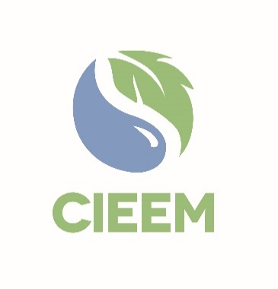 | Awards 2025  Postgraduate Student Project Award  Nomination Form

Please read the Awards Entry Guidance found on 2025 Awards | CIEEM webpage carefully before you begin to ensure you are aware of all the submission guidelines and judging criteria.

Student
Full Name*:
Membership number:
(If known)
Email:
☐ | I declare that to the best of my knowledge the information provided is accurate and complete.

* N.B.: These details will appear on any certificate/trophy should the nomination be shortlisted.

Project Supervisor
Full Name:
Membership number:
(If known/applicable)
Email:
☐ | I declare that to the best of my knowledge the information provided is accurate and complete.

At CIEEM, we are always looking to expand our new webinar programme. If the project is shortlisted for an award, would you be interested in giving a webinar? Yes ☐ No ☐

Nominations are assessed against the following six criteria:

1 | Project is presented well with appropriate structure, use of citations, bibliography and appendices, with a high standard of writing (style, punctuation, spelling and grammar), and a clear abstract / summary. | 10 points
2 | Evidence of consulting appropriate (particularly primary peer-reviewed literature) sources, using findings to support facts and arguments and show how the subject is positioned within the wider literature. Clearly focused literature search showing an awareness of current understanding and debate within the ecological and environmental management context of the project. | 15 points
3 | Clear and appropriate hypotheses / research questions are presented with clear explanation and justification of methods chosen to test them, limitations identified, and their implications discussed. | 15 points
4 | Evidence of an analytical / discriminating approach to the collection, evaluation and interpretation of data. Appropriate statistical analysis and manipulation / presentation of data, including effective use of figures and tables. | 25 points
5 | Evidence of critical evaluation with findings discussed fully and appropriately in the context of hypotheses, with limitations in methods and data evaluated. Evidence of understanding / impact of findings within wider context. | 25 points
6 | The project provides new evidence or information of relevance to ecology and environmental management in an applied context. | 10 points

Project/dissertation put forward for the CIEEM Postgraduate Student Project Award

(To be completed by Project Supervisor)
Title:
Awarding university/institution:
Please outline below why this project should receive a Postgraduate Student Award (maximum 500 words).

Your nomination text and supporting information will be the only pieces of information that the judges use in their shortlisting. Please be as specific and evidence based as possible when making the case for this project and be sure to address all eight award criteria.

Please email this entry form, your supporting information and three photos for use in the Awards presentation and booklet if shortlisted to awards@cieem.net by the closing date of 20th December 2024 Supporting information must be submitted as one PDF document, with a maximum of single six pages and with no more than three external links included. Please ensure you include any photos, maps, graphs and diagrams within the six-page limit. If you have any queries, please email or call 01962868626.

Nomination Check List
Student name provided and spell checked.
N.B. These details will appear on any certificate/trophy should the project be shortlisted.
Nomination text adheres to the word count – max 500 words.
Ensure any photos, maps, graphs and diagrams are only included within your six-page supporting information PDF and not in the nomination form.
N.B. Failure to comply with this may result in your nomination becoming ineligible.
Ensure your nomination form is submitted as a Word document.
Send three high quality photos alongside your nomination form and supporting information for use in the Awards presentation and booklet if shortlisted.

