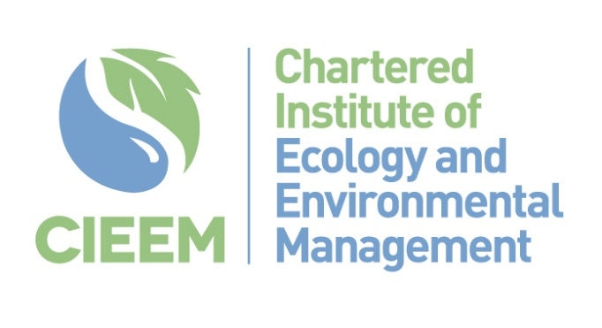

Capacity Research Project Ireland
Tender Proforma

Instructions to Tenderers
For each relevant section of your response, please specify how you will address the inclusion of Northern Ireland if you choose to do so. Detail any additional methodologies, stakeholder engagements, or specific analyses that will be employed to ensure the research encompasses both regions effectively.
Please return to enquiries@cieem.net by 5pm on 21st August 2024

1. | Please give the name, main address and contact details for correspondence  Name:  Position:  Company:  Address:  Telephone:  E-mail:  Website:  Do you have an Environmental Policy: Yes / No  (If “Yes” please supply a copy)
2. | Type of Company or Organisation (e.g. Limited, LLP etc.)
3. | Company Registration Number (where appropriate)
4. | If any of the following circumstances apply to your organisation, please provide details below and indicate how the potential conflict of interest would be managed:  - Partners, Directors or Senior Staff are employed by CIEEM  - Partners, Directors or Senior Staff have relative(s) employed by the CIEEM  - Partners, Directors or Senior Staff are employed by, or are related to, members of the CIEEM Governing Board
5 | Please identify who would be involved in delivering this brief, naming all key personnel and stating their specific roles (NB: CVs of key personnel can be included with the tender if desired but must be limited to two sides of A4):
6 | Please provide a detailed description of your team’s experience within the professional ecology sector and/or the field of educational development. Include specific examples of relevant projects that demonstrate your expertise and understanding of the nature-based green jobs market, with reference to the public, private, eNGO, and utilities sectors. Attach any supporting documents or web links to these examples. (Maximum 1000 words)
7 | Please describe your team’s understanding and technical experience in conducting stakeholder research and consultation projects. Highlight any relevant examples, particularly those focused on employment, training, and skills-based research. (Maximum 1000 words)
8 | Please describe your experience in preparing comprehensive research reports, specifically in relation to the areas outlined in this brief. Include examples of past reports where applicable. (Maximum 1000 words)
9 | Please outline your proposed approach to undertaking this work, with specific reference to the outputs required in the tender brief (NB: if invited to interview we will ask you to present this in more detail). (Maximum 1000 words)  Please provide a breakdown of the number of days you have allocated to this tender under the following headings.  - Stakeholder engagement  - 2.1 Research  - Report  - Creation of report and presentation materials
10 | Please provide your costs for delivering this tender brief. Costs should include all time allocated to the project and should be broken down using the headings as set out in section 11 above. Costs should be shown separately from VAT, but VAT-eligible items should be clearly indicated.
11 | Please explain how the contract will be managed internally and how you will manage any risks to delivery. (Maximum 500 words)
12 | Please describe any additional experience, skills or opportunities you could bring to this project. (Maximum 500 words)
1st referee
Company name:
Contact name:
e-mail address:
Tel no:
2nd referee
Company name:
Contact name:
e-mail address:
Tel no:

I confirm that I am authorised to submit this tender document on behalf of my company or organisation:

Name ________________________________________ Signature _____________________________

Position in company ______________________________________ Date________________________

Please return completed proforma to enquiries@cieem.net by 5pm. on 21st August 2024

