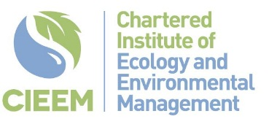

Sponsored by:

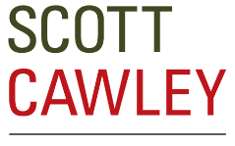

Financing the Future – Using Green Finance to Drive Nature’s Recovery
Summer CONFERENCE PROGRAMME – 16th july 2024 - ONLINE
SESSION 1. Chair: Penny Lewns CEcol CEnv MCIEEM, President Elect and Vice President (Wales)
9:30 | Welcome and Introduction – Penny Lewns CEcol CEnv MCIEEM, President Elect
9:35 | Making nature-markets work in the 21st century: lessons from Australia, England, and the EU  Dr Sophus zu Ermgassen, University of Oxford
10:00 | Biodiversity Net Gain provides a legacy for developing environmental markets for nature restoration  Prof David Hill CBE DL FCIEEM CEnv, Environment Bank
10.25 | Using ESG and financial disclosure mechanisms to drive action for nature  Morgan Taylor CEnv, Greengage Environmental
10:50 | Break
SESSION 2. Chair: Dr Caroline McParland CEnv MCIEEM, Vice President (Scotland)
11:20 | Practical experience of securing green finance  Dr Martina Girvan CEcol FCIEEM and Liam Price ACIEEM, Arcadis
11:45 | Innovating Scottish Nature Markets with Digital Nature Credits  Sophy Jones, Credit Nature
12.15 | The Nature of Finance – Assessing the nature-related Impact and Opportunities for Ireland’s Financial Sector  Thomas Ball, KPMG
12:40 | Lunch
SESSION 3. Chair: Ben Kite CEcol PIEMA MCIEEM, Chair of Strategic Policy Panel
13:40 | We see the wood and the trees - Our green finance journey  Johanna Bolhoven, Forestry England
14:05 | Nature North Investable Propositions  Francesca Moore and Laura Hobbs CEnv MCIEEM, Binnies
14:30 | Trees and Woodlands as Nature Based Solutions  Andrew Canning-Trigg MRTPI, Forestry Commission, Amy Carroll and Luke Thompson, Arup
14:55 | Break
SESSION 4. Chair: Dr Richard Handley CEcol MCIEEM, President
15:25 | The Challenges and Opportunities of Implementing Green Finance in Protected Landscapes  Jacob Parry, National Parks Partnership
15:50 | Putting opportunity into action – ReNature Credits in the South Downs National Park  Nick Heasman and Mark Alden, South Downs National Park Authority
16:15 | Green Finance for Islington Pocket Park Framework  Milimer Morgada PIEMA and Ludo Pittie FRSA FIPM, WSP
16:40 | Summary and Close – Richard Handley CEcol MCIEEM, President

