Invite to Tender for Ecological Survey works
March 2023
Date for Tender Submission – GMT Midnight 10th April 2023
The River Axe, flowing through Dorset, Somerset and Devon is a nationally significant river, with both designated SSSI and SAC status that has been badly damaged over many years by a combination of diffuse agricultural pollution and changes to the river’s morphology. Soluble reactive phosphorus and suspended solids are the main water quality drivers for its failure. The river exhibits a range of ecological problems associated with high phosphate concentrations, with algal communities smothering the riverbed and aquatic plants, silty river gravels and loss of salmonid spawning and juvenile river habitats. The problems affecting the SAC were first identified in the 1980s and many agencies and partners have since then attempted to resolve them, but the river remains in unfavourable condition and is declining.
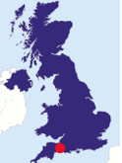
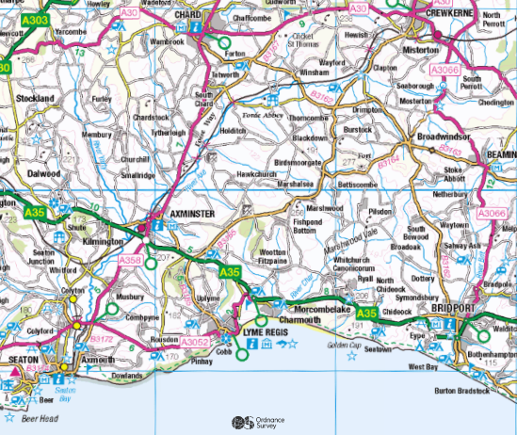

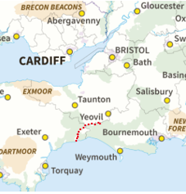

Recognising the importance of river restoration in the Axe, the Landscape Recovery project (one of 22 pilot projects in England), has been established. The 2 year development phase of the project encompasses 2023 and 2024, and during this time we will devise, in partnership with landowners in the upper Axe catchment, a solution to sustainably improving the river’s condition and its interconnectivity with the floodplain.
The Axe Landscape Recovery Project Vision:
We envision that, in 20 years’ time, The River Axe will interact with its floodplain function naturally once again to provide clean water, rich wildlife habitats, flood and drought mitigation and enhanced opportunity for people to access nature. Adjoining farmland is managed in a way which supports, enhances and connects these core riparian habitats as well as provide additional ecosystem services like food production, carbon sequestration and important terrestrial habitats.. As a result, people and wildlife flourish, living in a nature-rich, resilient landscape that sustains viable enterprises and the wellbeing and livelihoods of our communities.

Our partnership manages land along a total of 23.6km of the River Axe and its tributaries. The river channel and the fields immediately adjoining the river forming the floodplain form our Primary Area where we will target the most significant interventions. Across the wider Secondary Area our work will complement this core work via modification of farming practices incorporating regenerative farming principles and aims to re-naturalise land across the landscape.
Our objectives are to:
- Restore natural function to the river and tributaries throughout the Primary Area (shown in blue on the third map below), totalling 506ha.
- Restore spawning gravels in the Upper River Axe
- Reduce diffuse pollution entering the river system by 50%, targeting phosphates and suspended sediments originating from farming activities and sediments released directly from excessive channel erosion across 2010 ha (our Total Project Area).
To do this, we aim to:
- Make substantial interventions in the river such as installing large woody debris dams, re-armouring the river bed and restoring paleo-channels; these will reconnect the river to its floodplain, reduce bed and bank erosion and create vital fish spawning gravels.
- Install natural structures and adapt bank profiles in the smaller tributaries to create similar benefits.
- Convert arable land in the Primary Area to either woodland, wetland or extensive permanent pasture.
- Adopt extensive agricultural and silvicultural systems across a large proportion of the rest of the project area, via the modification of farming practices.
Ecological Surveying Requirements
To plan all the above, we need a better baseline understanding of what’s in the river and on the floodplain.
Therefore, we are inviting tenders for ecological surveys on which we can base plans for habitat creation and enhancement. Ecological surveys will need to be thorough enough for us to plan habitat changes with confidence, but targeted enough to focus on areas of greatest ecological importance.
We already have landowner permission for those surveys to be carried out and can provide contact details for the surveyor to plan the visits with the landowners.
Julian Payne of the Environment Agency will be conducting an initial walk of the river course over 6 days to assess the hydrological surveying requirements for the project. This report will be available to the successful tender applicant by June 1st 2023
We can provide the following mapping shapefiles for the area we require surveying for: field boundaries, field land cover (permanent grassland, woodland, arable land), river and tributary shapefiles, contours.
By the end of summer 2023 we need to know:

Existing habitat and land use types categorised according to the UK Habitat Classification including habitat condition assessments on the floodplains and land adjacent to watercourses. This needs to be in a format which can be used for Biodiversity Net Gain projects in the future. | Fixed price quote
The presence and spread (determined or estimated) of important species for conservation or control (invasive species) in the rivers (Axe, the Cricket St Thomas stream, Hewood stream and Synderford), and important habitat features for those species in the river channels. | Fixed price quote
The condition of the riverbanks and riverbeds | Fixed price quote
Botanical survey data on specific pieces of land (particularly unimproved grassland), some identified already, others to be identified by your initial surveys. | Priced per hectare
We expect the outputs as GIS shapefiles which we can amalgamate into our overall project mapping. Any mapping output should be send as jpeg rather than pdf.
By the end of summer 2024 we expect we will need to know:
Our project will develop as we engage the landowners and produce initial assessments of the land. At present we do not know the exact requirements for further sampling. Please could you provide a unit cost for the below (per day or per ha).

Further botanical survey data on land away from the floodplain. | Priced per hectare
Further detailed protected species surveys on sites where river restoration works are proposed.
Surveys for key indicator species such as birds, bats, butterflies. | Priced per day
Other survey data, yet to be determined | Priced per day

Please give details in your tender of:
- Your experience / suitability for carrying out this work
- Prices
- Timescales
- Proposed surveying methods
- How you will collate and present the data
- Any further suggestions of what we should be including in our baseline surveys

For further information, please email info@upperaxe.org.uk

