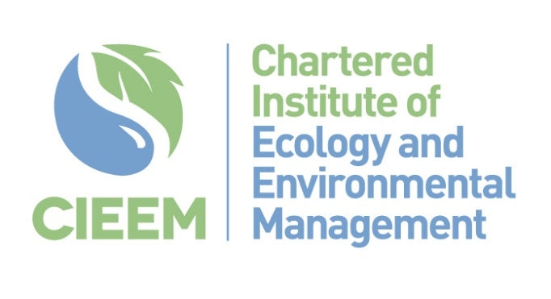

Non-degree Entry to Nature-based Green Jobs Research Project

Tender Proforma

Please return to enquiries@cieem.net by 12 noon on 27th January 2023
1. | Please give the name, main address and contact details for correspondence  Name:  Position:  Company:  Address:  Telephone:  E-mail:  Website:  Do you have an Environmental Policy: Yes / No  (If “Yes” please supply a copy)
2. | Type of Company or Organisation (e.g. Limited, LLP etc.)
3. | Company Registration Number (where appropriate)
4. | If any of the following circumstances apply to your organisation, please provide details below and indicate how the potential conflict of interest would be managed:  - Partners, Directors or Senior Staff are employed by CIEEM or Lantra  - Partners, Directors or Senior Staff have relative(s) employed by the CIEEM or Lantra  - Partners, Directors or Senior Staff are employed by, or are related to, members of the CIEEM Governing Board or the Lantra Board of Trustees
5 | Please identify who would be involved in delivering this brief, naming all key personnel and stating their specific roles (NB: CVs of key personnel should be included with the tender but must be limited to two sides of A4):
6 | Please describe you/your team’s understanding and technical experience of undertaking stakeholder research and consultation projects. If possible give examples relevant to employment, training and skills-based research. (Maximum 1000 words)
7 | Please describe you/your team’s understanding of and links to the nature-based green jobs market with reference to the public, private, eNGO and utilities sectors. (Maximum 1000 words)
8 | Please outline you/your team’s knowledge of vocational post-16 education and training provision across the UK and Ireland relevant to nature-focused green jobs. (Maximum 750 words)
9 | Please outline your proposed approach to undertaking this work, with specific reference to the outputs required in the tender brief. (Maximum 1000 words)
10 | Please describe you/your team’s experience in delivering projects to tight deadlines, outlining how the contract will be managed internally and how you will manage any risks to project delivery. (Maximum 750 words)
11 | Please describe any additional experience, skills or opportunities you/your team could bring to this project. (Maximum 750 words)
12 | Please provide a breakdown of the number of days you have allocated to this tender. Please use the following headings:  Attendance at online project management meetings.  Desk-based research  Designing and delivering stakeholder consultation  Data analysis and report writing  Contingency
13 | Please provide your costs for delivering this tender brief. Costs should include all time allocated to the project and should be broken down using the headings as set out in section 12 above. Costs should be shown separately from VAT but VAT-eligible items should be clearly indicated.
14 | Please provide two references from organisations that you/your project team have previously worked for. At least one of these referees should be able to comment on you/your team’s expertise in vocational training and qualifications in the environmental sector, at least one should be able to comment on you/your team’s research experience
1st referee
Company name:
Contact name:
e-mail address:
Tel no:
2nd referee
Company name:
Contact name:
e-mail address:
Tel no:

I confirm that I am authorised to submit this tender document on behalf of my company or organisation:

Name ________________________________________ Signature _____________________________

Position in company ______________________________________ Date________________________

Please return completed proforma to enquiries@cieem.net by 12 noon. on 27th January 2023

