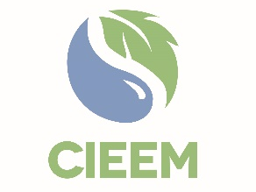
2021 Awards Winners and Finalists
Category | Sponsor | Shortlisted Project/Individual | Results
Best Practice - Innovation |  | Warblington Farm Nature Reserve and Havant Borough Council’s Mitigation Plan for Nutrient Neutral Development – Havant Borough Council | Winner
 |  | East West Rail 2 (EWR2) – East West Rail Alliance | Highly Commended
 |  | Using Immersive Technology to maximise communication of ecological design – AECOM | Commended
 |  | 360° Imaging – Environment Agency & Grow2Know | Commended
Best Practice – Knowledge Sharing |  | Ecosystems Knowledge Network | Winner
 |  | The Plastics Project, Mott Macdonald | Highly Commended
 |  | My Wild City – Engaging People with Urban Nature | Commended
Best Practice – Practical Nature Conservation (Large-Scale) | 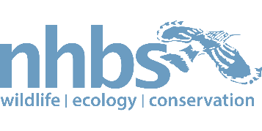 | Lancashire Peatlands Initiative – Lancashire Wildlife Trust | Winner
 |  | Tetney Blow Wells SSSI Restoration – Anglian Water | Highly Commended
Best Practice – Project Mitigation (Small-Scale) |  | Llwyn Celyn Restoration Project – Wildwood Ecology and The Landmark Trust | Winner
 |  | Balsall Common STW Badger Pass – Thomas Wright, Severn Trent | Highly Commended
 |  | Howdon Satellite Rail Depot (Ecological Mitigation Strategy) – Nexus, Atkins, Conops Entomology, EcoNorth | Highly Commended
Best Practice – Project Mitigation (Large-Scale) |  | Sudbrook Papermill Site, Arcadis | Winner
Best Practice – Stakeholder Engagement |  | Havant Thicket Reservoir, Portsmouth Water, Atkins, Create 51 and Agilia | Winner
Action 2030 |  | Global Climate Change: Strengthening Understanding of the Economic Impacts of Climate Change – Dialogue Matters working with Grantham Inst, Oxford University and BEIS | Winner
 |  | Thames Water’s company commitment on Biodiversity Net Gain, Thames Water | Highly Commended
 |  | Joshua Styles MCIEEM | Commended
Member of the Year |  | David Whitehorne CEnv MCIEEM | Winner
 |  | Paola Reason CEcol CEnv FCIEEM | Winner
 |  | Mark Lang CEcol CEnv MCIEEM | Commended
Promising Professional |  | Kimberley Doneo | Winner
 |  | Joseph D’Souza | Highly Commended
 |  | Maico Geert Weites | Highly Commended
 |  | Mariko Whyte | Highly Commended
NGO Impact |  | The Red List for British Mammals – The Mammal Society | Winner
 |  | BatChat Podcast – Bat Conservation Trust | Highly Commended
 |  | The UK Habitat Classification – UKHab Ltd | Highly Commended
Consultancy of the Year (Small) |  | Wildwood Ecology Ltd | Winner
 |  | Ecology by Design | Highly Commended
Consultancy of the Year (Medium |  | JBA Consulting Ltd | Winner
 |  | BSG Ecology | Highly Commended
Consultancy of the Year (Large) |  | Jacobs | Winner
 |  | Atkins | Highly Commended
 |  | RSK Biocensus | Highly Commended
 |  | Arcadis Consulting (UK) Ltd | Commended
 |  | WSP | Commended
Planning Authority of the Year |  | Telford & Wrekin Council | Winner
In Practice Article |  | Solent Nutrients: an opportunity to build back better? by Allison Potts, David Hayward & Debbie Tann (December 2020) | Winner
 |  | Nitrogen Neutrality Within the Solent Region – An Ecologist’s View by David West (December 2020) | Highly Commended
 |  | Seize the moment – New Approaches for Fresh Momentum by Diana Pound (September 2020) | Highly Commended

