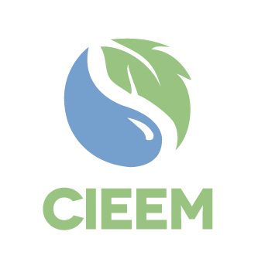
Farm Environment Adviser Competency Framework – Feedback Form

Name
Organisation
Role in relation to farm environmental advice (e.g. adviser, trainer, farmer/landowner, policy maker, funder, stakeholder organisation).
Overall comments on the draft Competency Framework
What are your thoughts on the three levels (Trainee; Proficient; Advanced)? Are they about right?
What are your thoughts on the 16 competencies? What is missing and/or what shouldn’t be there?
Would you like to be contacted to follow up on your feedback? | Yes/No
If yes, what is your email address?
Any other comments?

Please return this form to farmadvice@cieem.net.*

* Please note this data will be held by CIEEM as the data controller and shared with Plantlife as the project partner.

