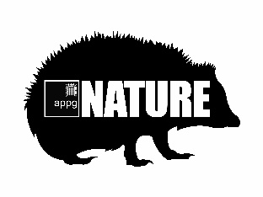
All-Party Parliamentary Group for Nature

Application for Associate Membership

PERSONAL DETAILS of representative
Surname: |  | Forename(s): |  | Title:
Email: |  | Contact Address:
Contact number:

How did you learn about the APPG for Nature?

Organisation DETAILS (If applicable)
Name of Organisation:
Type of Organisation (e.g. NGO, Statutory, Consultancy):
Reason for Joining the APPG for Nature:

PAYMENT INFORMATION
- Your membership of the APPG for Nature will be valid for one year following payment. We will issue a reminder via email when your membership is approaching its end date, at which point you can decide whether to renew.
- Your application will be acknowledged upon receipt and an invoice raised for payment within CIEEM’s terms.
Once we have received your completed form an invoice will be generated, and we will send you an email with more information about how to pay. If you require your invoice to be made out to a different address than that provided below, please contact APPGforNature@cieem.net.

 | Please raise an invoice with the below details:
Invoice to: |  |  | Invoice details:  (i.e. PO number)
Invoice address:
Invoice email:

DECLARATION BY APPLICANT
By entering my name in the box below, I certify that the information in this application to be true and correct, to the best of my knowledge, and that this information can be used for the purpose of processing my application for Associate Membership subject to approval by the Secretariat of the All Party Parliamentary Group (APPG) for Nature.
I agree that details pertinent to my application and membership history will be held and used by the Chartered Institute of Ecology and Environmental Management, as Secretariat for the APPG for Nature, under the terms of the Data Protection Act 1998, for the purposes of establishing and maintaining membership of, or support for, the APPG for Nature or providing and administering activities for members.
I understand that my application for membership may be refused, or my membership may be later withdrawn, if I have provided false or untrue information.
Signed: |  | Date:

When you’re ready to submit your application, please email a copy to APPGforNature@cieem.net.

Please ensure that you have filled out this form fully and accurately.

